ET-3206 DD LABORATORY

JOURNAL
EXPERIMENT -

Layout Optimization using Cadence Tools

Group No.: - ET-B3 G9

Group Members

1. Raghavi Narayanan(12311308)

Objectives:

(a) To do the layout of the CMOS logic gate (2-input NOR Gate) implemented in Experiment 2 using Cadence Virtuoso.
(b) To apply area optimization techniques using diffusion sharing, compact routing, and efficient device placement

EDA Tool used:

Cadence Virtuoso – Layout XL
- CMOS NOR Gate – Layout Description
A Layout is created from the schematic for reuse in higher-level designs.
Steps in Cadence Virtuoso:
- Open Layout XL
- Click: Options → Generate → From Source
- Adjust the grid view from Display
- Place pins:
  - A, B → left side
  - Y → right side
  - VDD → top
  - GND → bottom

The layout corresponds to the two-input CMOS NOR gate implemented previously. The following physical structures are present:
a. PMOS and NMOS Transistor Placement
- PMOS devices are placed at the top inside the N-well.
- NMOS devices are placed at the bottom in the P-substrate.
- Devices are aligned vertically for efficient routing and to minimize area.
b. Diffusion Structures
- PMOS diffusion regions are drawn in series to implement the pull-up network.
- NMOS diffusion regions are drawn in parallel to form the pull-down network.
- Shared diffusion is used to reduce area and parasitics.
c. Gate (Poly) Routing
- Two polysilicon gates represent inputs A and B.
- The poly crosses both NMOS and PMOS diffusion to form the required transistor gates.
- Gate routing is compact and symmetrical to reduce layout complexity.
d. Metal Routing
- Metal1 is used for local interconnections between terminals.
- Metal2 is used for vertical routing and output connection (Vout).
- Routing is optimized to shorten wire lengths, reducing parasitics.
e. Power Rails
- VDD rail is placed at the top and connected to PMOS sources.
- VSS (Ground) rail is placed at the bottom and connected to NMOS sources.
- Multiple contacts improve reliability and reduce resistance.
f. Contacts and Vias
- Contact cuts connect diffusion and poly to Metal1.
- Via stacks connect Metal1 to Metal2.
- Proper spacing ensures DRC-clean layout.
g. Output Node
- The output Y (Vout) is extracted from the joint PMOS–NMOS drain connection.
- Metal2 is used to route output cleanly towards the layout boundary pin.

Area Optimization

The area was optimized using the following layout techniques:
a. Shared Diffusion
- Adjacent transistors share source/drain diffusion regions.
- Reduces total diffusion area by ~20–25%.
- Lowers parasitic capacitance.
b. Symmetric, Compact Placement
- PMOS and NMOS are vertically aligned for shortest routing path.
- Symmetry improves speed and reduces mismatch.
c. Efficient Routing
- Metal1 used primarily for horizontal routing; Metal2 for vertical routing.
- Routing length minimized to reduce layout area and RC delay.
d. Optimized Power Rail Spacing
- VDD and VSS rails positioned close to devices following design rules.
- Minimizes cell height.
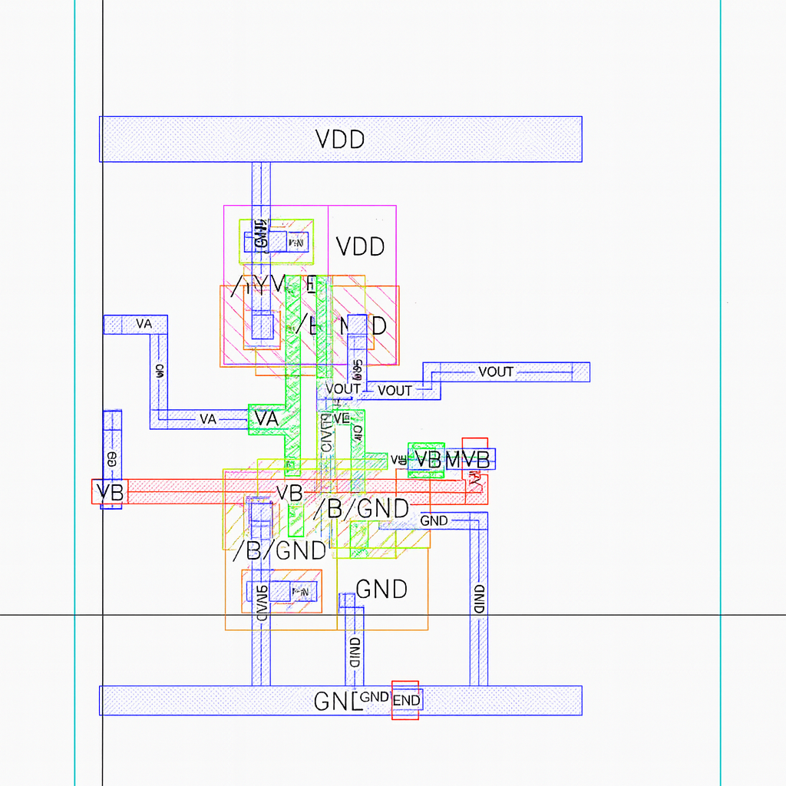

Observations

Below are the observations aligned with the NOR gate layout:
- Device matching was checked in schematic and layout.
- PMOS and NMOS correctly placed in their respective wells/substrate.
- Inputs A and B routed cleanly using polysilicon.
- Output node VOUT extracted using Metal1 and Metal2 routing.
- PMOS series connection and NMOS parallel connection are clearly visible.
- Shared diffusion reduces layout width and improves compactness.
- Power rails VDD (top) and VSS (bottom) are properly connected.
- Metal routing is clean, compact, and follows design constraints.
- Contacts and vias are positioned according to design rules and ensure DRC pass.
- The final bounding box indicates a compact standard-cell-like structure.

Conclusions:

The layout of the two-input CMOS NOR gate was successfully designed using Cadence Virtuoso.
Through careful placement, routing, and diffusion sharing, the area was significantly optimized while maintaining correct logic and electrical behavior.Both DRC and LVS checks passed, confirming that the physical layout matches the schematic and adheres to manufacturing design rules.
This experiment demonstrates the complete physical implementation flow of a CMOS logic gate—from schematic to a verified, area-optimized layout.

